Ideation Phase

Brainstorm & Idea Prioritization Template

|  |  |
| --- | --- |
| Date | 19 September 2022 |
| Team ID | PNT2022TMID42037 |
| Project Name | Efficient Water Quality Analysis and Prediction  using Machine Learning |
| Maximum Marks | 4 Marks |

Brainstorm & Idea Prioritization Template:

Step-1: Team Gathering, Collaboration and Select the Problem Statement

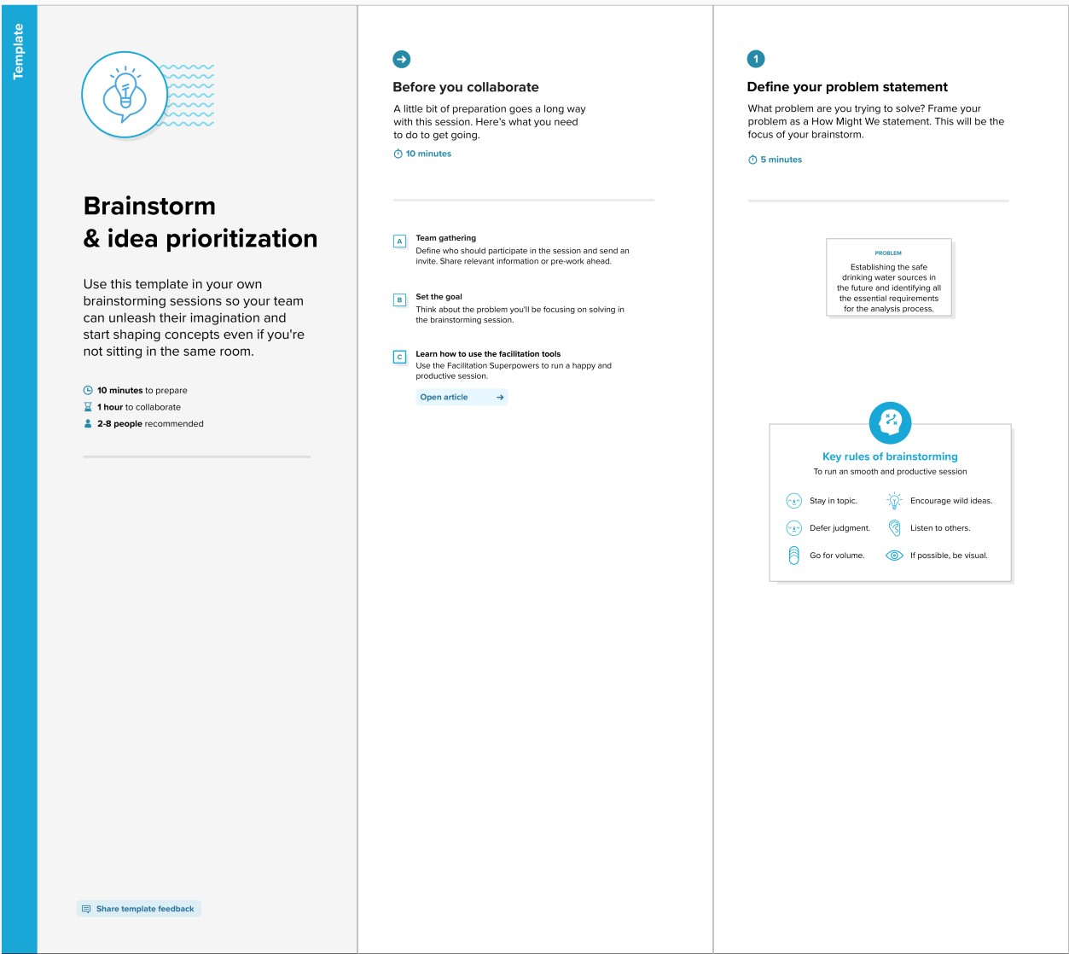

**Step-2: Brainstorm, Idea Listing and Grouping**

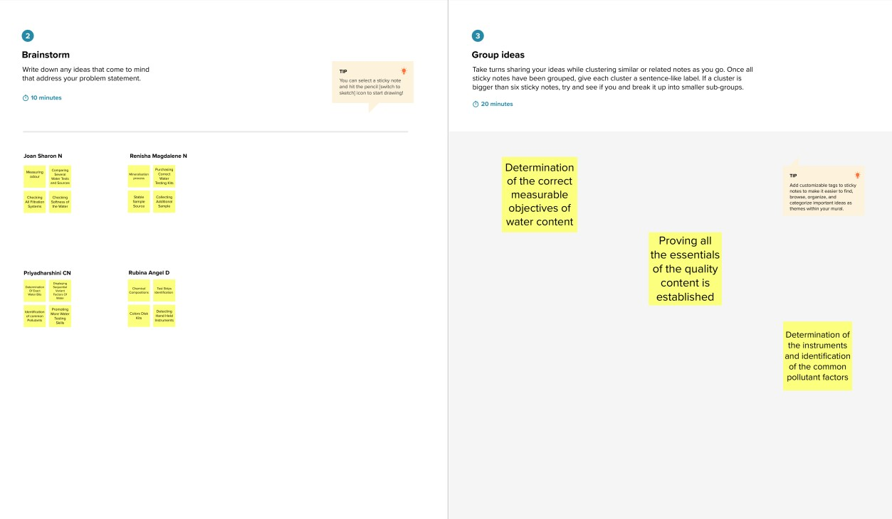

**Step-3: Idea Prioritization**

